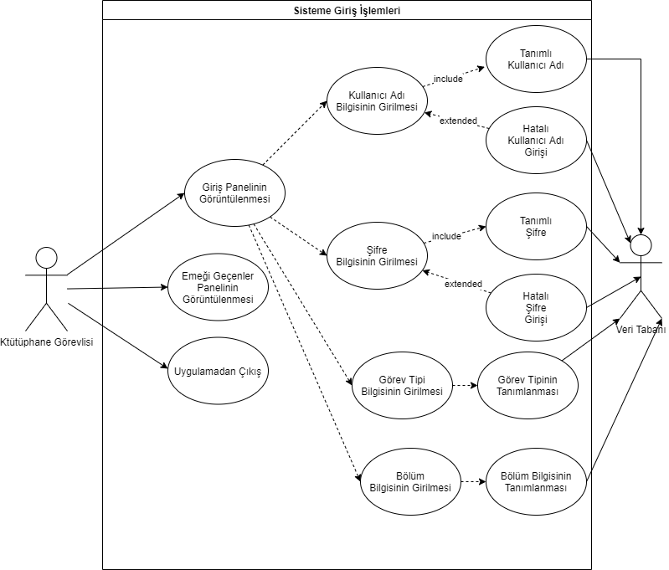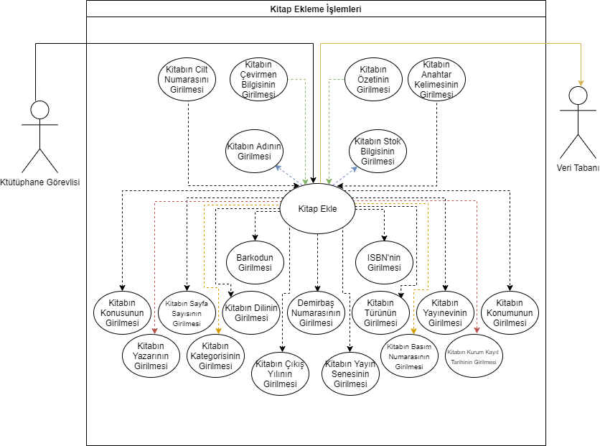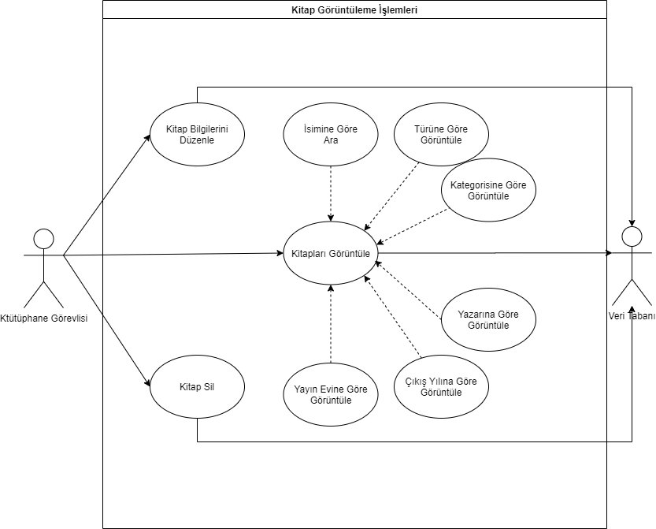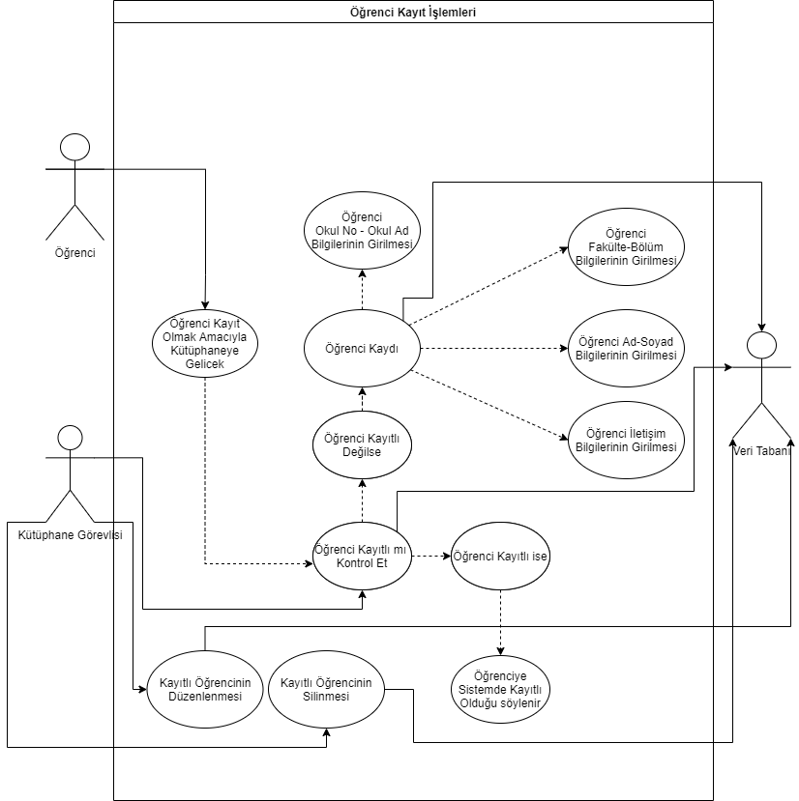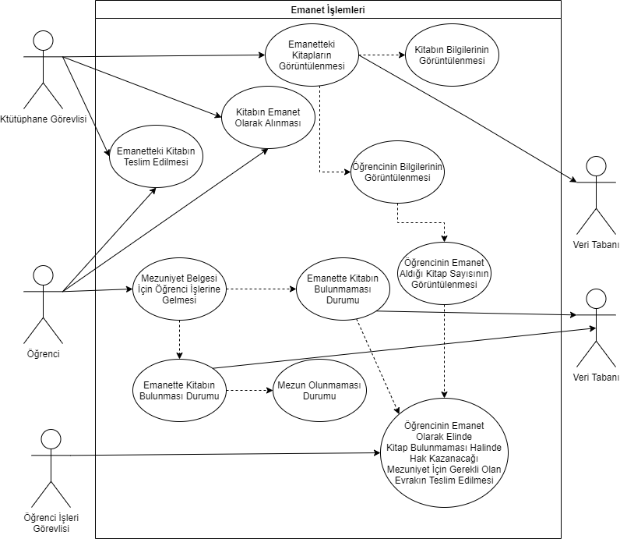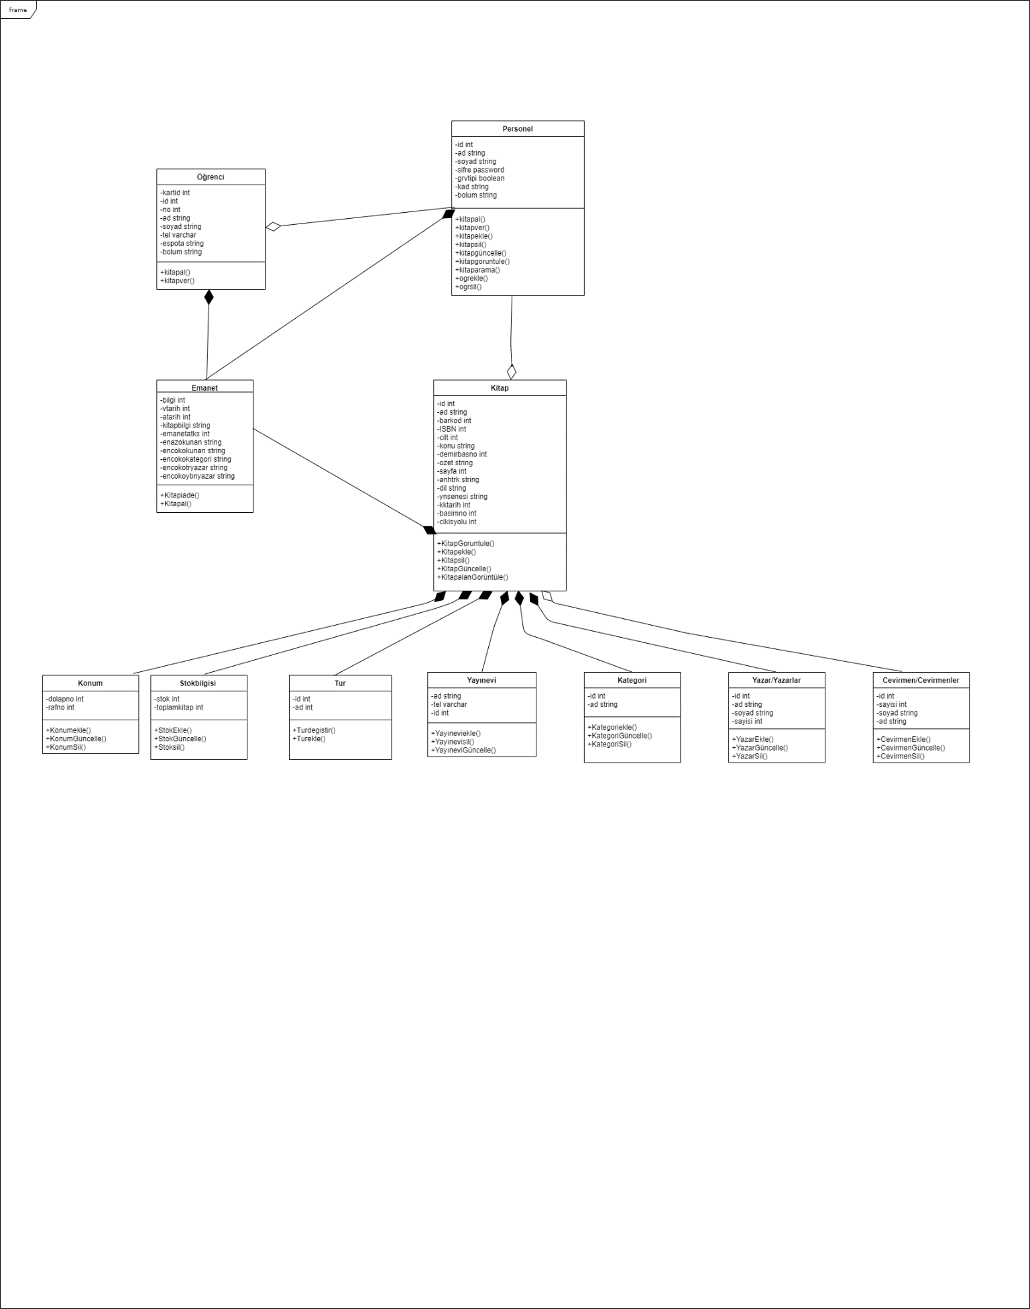

**Source Software Ekibi**  
Halil Eren Yazıcı : 132030049  
Berkay Gürcan : 132030022  
Baha Can : 131830066  
Mustafa Kaya : 131930068  
Kadir Korkmaz : 132030046